SIMATS ENGINEERING (SAVEETHA SCHOOL OF ENGINEERING)
Department of Computer Science and Engineering
ASSESSMENT TOOL 1 – Prompt Engineering Challenge

Course Code: | CSA65 | Course Title: | Generative AI and Large Language Models
CO Assessed: | CO2 – Precision (BL1, BL2) | Assessment: | Assessment Tool 3 – Prompt Engineering Challenge
Weightage: | 40% of CIA | Total Marks: | 100 (2 Question)
CO1 Statement: | Apply prompt engineering techniques and utilize pre-trained Large Language Models through modern AI frameworks and APIs to solve real-world problems.(BL1, BL2)
Student Name: | N Goutham | Reg. No.: | 192472024
Section / Batch: | CSE-AI | Date: | 28-07-2026

Instructions to Students
•Answer 2 questions. Each question carries 50 Marks. Total: 100 Marks.
• Write clear, well-structured prompts and explanations where asked.
• Use your own original examples — do not copy from classmates or the internet verbatim.
• Where a diagram or worked example is requested, label it clearly.
• Illustrate prompting techniques (zero-shot, few-shot, chain-of-thought, role/system prompting, etc.) with concrete examples, not just definitions.
Time allotted: 30 mins

Code of Conduct
I N Goutham(192472024) (Name / Reg No) certify that this submission is my original work and that I have adhered to the guidelines specified for this assessment. I understand that any violation of academic integrity rules will result in disciplinary action.
Signature of the Student: N Goutham

SECTION A – PROMPT ENGINEERING CHALLENGE
Q1. Zero-Shot Extraction
Write a zero-shot prompt that takes a paragraph of text and extracts all person names, dates, and locations into a clean list — without giving the model any examples.

Aim
To extract all person names, dates, and locations from a paragraph using a Zero-shot Prompt without providing any examples.

Technique Used : Zero-Shot Prompting

Why this Technique?
Zero-shot prompting provides only instructions without any examples. The model relies on its pretrained knowledge to extract the required information.

Algorithm
- Install the Gemini API library.
- Import the required package.
- Initialize the Gemini client using the API key.
- Create a Zero-shot prompt with extraction instructions.
- Provide the paragraph as input.
- Generate the extracted entities.
- Display the output in a structured format.

Sample Input

from google import genai

# Replace with your Gemini API Key

client = genai.Client(api_key="YOUR_GEMINI_API_KEY")

paragraph = """

On 10 July 2026, Dr. Meera Krishnan visited the Indian Institute of Science in Bengaluru to attend an Artificial Intelligence conference. She met Professor Arjun Rao and researcher Neha Sharma to discuss collaborative research projects. Later, the team traveled to Hyderabad on 15 July 2026 to present their work at an international seminar.

"""

prompt = f"""

You are an expert information extraction assistant.

Read the paragraph below and extract:

1. Person Names

2. Dates

3. Locations

Instructions:

- Extract only explicitly mentioned information.

- Do not guess.

- Remove duplicates.

- Return the output in this format:

Person Names:

Dates:

Locations:

Paragraph:

{paragraph}

"""

response = client.models.generate_content(

model="gemini-2.5-flash",

contents=prompt

)

print(response.text)

Expected Output

Person Names:

- Dr. Meera Krishnan

- Professor Arjun Rao

- Neha Sharma

Dates:

- 10 July 2026

- 15 July 2026

Locations:

- Indian Institute of Science

- Bengaluru

- Hyderabad

Output Screenshot

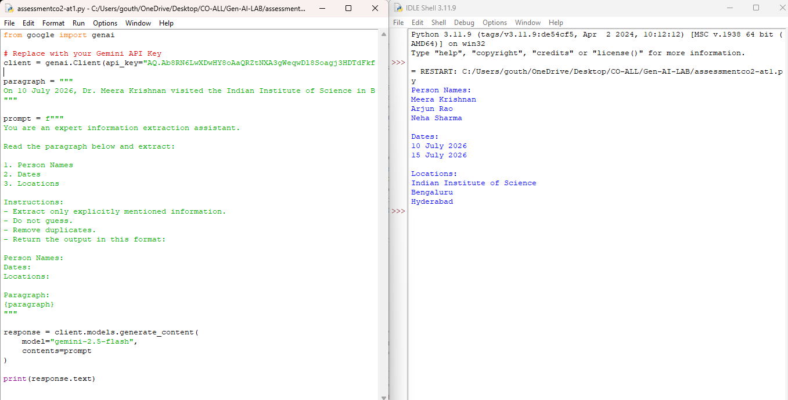

Result
The Zero-shot prompt successfully extracted all person names, dates, and locations from the given paragraph without using any examples.

Q6. Prompt Chaining
Design a 2-step prompt chain: Step 1 summarizes a long article; Step 2 takes that summary and generates 3 quiz questions from it. Write both prompts and show how Step 1's output feeds Step 2.

Aim
To design a two-step prompt chain where the first prompt summarizes a long article and the second prompt generates quiz questions from the generated summary.

Technique Used : Prompt Chaining

Why this Technique?
Prompt chaining breaks a complex task into smaller sequential tasks. The first prompt summarizes the article, and the second prompt uses that summary to generate quiz questions. This improves accuracy and modularity.

Algorithm
- Install the Gemini API library.
- Import the required package.
- Initialize the Gemini client.
- Create Prompt 1 to summarize the article.
- Store the generated summary.
- Pass the summary to Prompt 2.
- Generate three quiz questions with answers.
- Display both outputs.
Sample Input

from google import genai

# Replace with your Gemini API Key
client = genai.Client(api_key="YOUR_GEMINI_API_KEY")

article = """
Artificial Intelligence (AI) is transforming industries across the world.
In healthcare, AI helps doctors detect diseases earlier and improve patient care.
In education, AI-powered tutoring systems provide personalized learning experiences.
Businesses use AI through chatbots, forecasting, and data analysis.
Transportation companies are developing self-driving vehicles.
Despite these benefits, AI raises concerns regarding privacy, bias, and job displacement.
Researchers are working to develop ethical AI systems.
"""

# Step 1 - Summarization
summary_prompt = f"""
Summarize the following article in about 120 words.

Article:
{article}
"""

summary = client.models.generate_content(
model="gemini-2.5-flash",
contents=summary_prompt
).text

print("========== SUMMARY ==========")
print(summary)

# Step 2 - Quiz Generation
quiz_prompt = f"""
Using ONLY the summary below, generate exactly three quiz questions with answers.

Summary:
{summary}
"""

quiz = client.models.generate_content(
model="gemini-2.5-flash",
contents=quiz_prompt
)

print("\n========== QUIZ ==========")
print(quiz.text)

Sample Output 1 :

Artificial Intelligence (AI) is profoundly transforming industries globally. In healthcare, AI assists doctors in early disease detection and enhances patient care, while education benefits from AI-powered tutoring systems that provide personalized learning experiences. Businesses leverage AI through chatbots, forecasting, and data analysis to improve operations and customer service. The transportation sector is also seeing advancements with the development of self-driving vehicles.

Despite these significant advantages, AI raises important concerns. Issues such as privacy breaches, algorithmic bias, and potential job displacement due to automation are critical challenges. Consequently, researchers are actively working to develop ethical AI systems, aiming to mitigate these risks and ensure AI's responsible and beneficial integration into society.

Sample Output 2 :

1. Question: According to the summary, name two industries benefiting from AI and describe one specific application in each.
Answer: Healthcare, where AI assists doctors in early disease detection; and Education, which benefits from AI-powered tutoring systems providing personalized learning experiences. (Other acceptable pairs include Businesses: chatbots/forecasting/data analysis; Transportation: self-driving vehicles).

2. Question: What are three critical challenges or concerns raised by Artificial Intelligence, as mentioned in the summary?
Answer: Privacy breaches, algorithmic bias, and potential job displacement due to automation.

3. Question: According to the summary, what are researchers actively working to develop regarding AI, and what is their primary aim?
Answer: Researchers are actively working to develop ethical AI systems. Their primary aim is to mitigate risks and ensure AI's responsible and beneficial integration into society.
Output Screenshot :
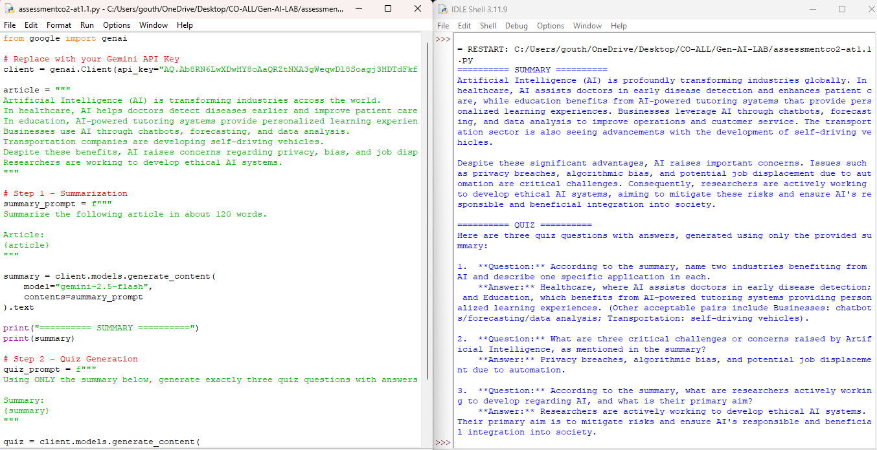

Result
The prompt chain successfully summarized the article in Step 1 and used the generated summary in Step 2 to create three relevant quiz questions with answers, demonstrating effective sequential prompt chaining.

RUBRICS FOR CALCULATION
Criteria | Wt. | Level 4 (Exemplary) | Level 3 (Proficient) | Level 2 (Developing) | Level 1 (Beginning)
Technique Selection | 30% | Correctly applies zero-shot/one-shot/few-shot & CoT technique appropriate to each task | Applies techniques with minor mismatch to task | Limited understanding of which technique to use | Techniques applied incorrectly or not evident
Output Effectiveness | 25% | Prompts produce accurate, task-appropriate outputs across all assigned tasks | Prompts work well for most tasks | Prompts work for only a few tasks | Prompts are largely ineffective
Prompt Craftsmanship | 20% | Prompts are clear, specific, and reusable | Prompts are mostly clear | Prompts are vague or inconsistent | Prompts are poorly constructed
Prompt-Output Documentation | 15% | Well-documented prompt-output pairs with clear rationale | Documented with minor gaps | Minimal documentation of prompts/outputs | No rationale provided for prompt choices
Design Rationale | 10% | Clearly explains design choices and iterations made | Explains most design choices | Limited explanation of process | No explanation of process provided

Marks Evaluation:
Question No. | Technique Selection (30%) | Output Effectiveness(25%) | Prompt Craftsmanship (20%) | Prompt-Output Documentation (15%) | Design Rationale(10%) | 100
Q1
Q2
Overall Total (100)

Faculty In-charge | Course Coordinator | Head of Department
Signature: _______________ | Signature: _______________ | Signature: _______________
Date: ___________________ | Date: ___________________ | Date: ___________________

